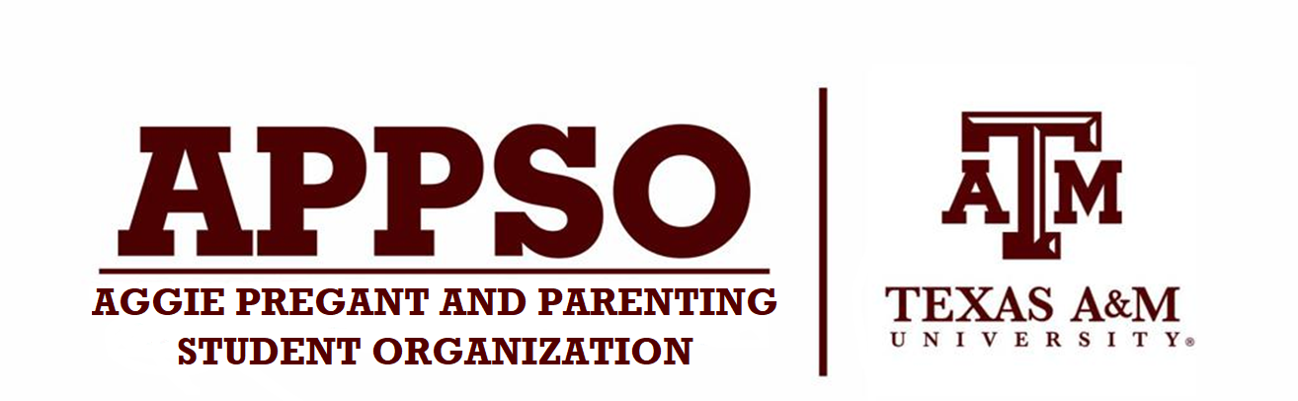

2024 Scholarship Application
We are thankful for the numerous donations we have received in the past two years that have enabled us to provide our first scholarship opportunity. Currently, there are no scholarships catered specifically for the financial needs of student-parents or pregnant people through the financial aid office or through student programs. The Aggie Pregnant and Parenting Student Scholarship was created to fund student tuition, childcare services (proof of enrollment required), and aid in the professional development of active members by funding costs associated with presenting at conferences. The mission of the Aggie Pregnant and Parenting Student Organization is to create a supportive community at Texas A&M to help student-parents navigate through parenthood and academics. It is our goal to begin a scholarship program so that we can help support student-parents that are active members of our organization reach their academic goals. Two students will be selected to receive a $250 scholarship and funds will be distributed through the Texas A&M student business services and/or financial organization office via direct deposit or check. If selected, you are required to write no more than a half-page appreciation letter stating how the scholarship funds were helpful to you and your overall academic success at Texas A&M.
Applicants must meet the following criteria:
- Be an active member of the Aggie Parent and Pregnant Organization. Officers are eligible to apply.
- Must be registered full time at Texas A&M University. A minimum of 12 credit hours for undergraduate students and 9 credit hours for graduate students.
- Have a minimum of a 3.0 GPA
- Demonstrate a need for financial support which will be evaluated based on financial aid, student income, and other financial assistance.
- Only one member per household will be eligible for the scholarship.
Please complete and submit this application by email as an attachment to appsoatm@gmail.com
APPLICATIONS ARE DUE NO LATER THAN 11:59 PM on
Friday, March 8, 2024
SELECTED RECIPIENT(S) WILL BE NOTIFIED BY
Friday, March 29th, 2024
Please direct any inquiries to appsoatm@gmail.com.
Thanks & Gig ‘em!

Aggie Pregnant and Parenting Student Organization

Pregnant & Parenting Student Scholarship Application
Awarded Spring 2024
Name: ______________________________________________
Phone Number: _________________________________
Address: ______________________________________________________________________________ Date of birth: ______________________
UIN: _______________________
Expected Graduation Date: ______________
Are you a graduate or undergraduate student? _________________
Major: _____________ Minor: _________________
Total number of credit hours enrolled for the current semester: _____ Cumulative GPA: ___________ Please attach a copy of your unofficial transcript and registration schedule*
Are you currently pregnant? Yes______ No______
If so, due date:
How many children do you have? __________
If so, please list gender and age:
Are you married or single? ___________
If married, is the other parent a college student? Yes________ No______
If married, Is the other parent currently employed? Yes______ No______
Including yourself, how many people live in your household? _________________
Do you currently have health coverage for you and your child(ren)? Yes______
If not, are you currently on Medicaid? Yes______
Do you receive any type of financial aid? Check all that apply and list names if applicable to you. ● Grants ______________________________________________________
● Scholarships _________________________________________________
● Stafford Unsubsidized Loan _____________________________________
● Private loan _________________________________________________
● PLUS loan ___________________________________________________
● Stafford Subsidized Loan _______________________________________
● Fellowship__________________________________________________
● Other: _____________________________________________________
Are you currently employed? Yes_______ No_______
If yes, full or part time? ________________________________

Please answer each of the following questions on a separate sheet of paper in approximately 50-250 words per question:
- If awarded this scholarship, how do you anticipate using the funding? Please include documentation to justify the need for the following categories:
- School tuition: Active/Outstanding balance on student account
- Childcare services: Proof of enrollment or bill
- Professional conference: Registration invoice, travel budget, proof of abstract submission, and/or meeting schedule.
2. What type of financial burdens have you experienced as a student-parent?
3. What type of programs, services, and/or events would you like to see Aggie Pregnant and Parenting Student Organization offer you as a parenting student?
4. Would you like to add any further information concerning parental rights and responsibilities that will help us evaluate your financial situation?

